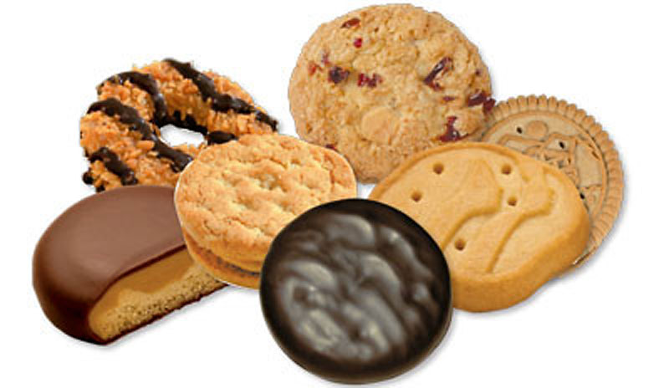



Everyone loves Girl Scouts cookies! In this assignment you will track cookie orders for each variety of cookie. A CookieOrder specifies the variety of cookie and the number of boxes ordered for one Girl Scout. A partial declaration of the CookieOrder class is shown below.

public class CookieOrder {

private String cookieVariety;

private int boxes;

public CookieOrder (String variety, int numBoxes) { . . . }

public String getVariety() { . . . }

public int getNumBoxes() { . . . }

public String toString() { . . . }

}

The MasterOrder class maintains a list of cookies to be ordered. A partial declaration of the MasterOrder class is shown below.

public class MasterOrder {

private List<CookieOrder> orders;

public MasterOrder() { . . . }

public void addOrder (CookieOrder theOrder) { . . . }

public int getTotalBoxes() { . . . }

public int removeVariety (String cookieVar) { . . . }

public String toString() { . . . }

}

Complete missing implementation for all methods.

The addOrder method adds theOrder to the end of the orders list.

The getTotalBoxes method computes and returns the sum of the number of boxes of all cookie orders. If there are no cookie orders in the master order, the method return 0.

The removeVariety method updates the master order by removing all the cookie orders in which the variety of cookie matches the parameter cookieVar. The master order may contain zero or more cookie orders with the same variety as cookieVar. The method returns the total number of boxes removed from the master order.

Include the following statements in your tester:

MasterOrder myOrder = new MasterOrder();

System.out.println (“There are “ + myOrder.getTotalBoxes() + “ boxes of cookies” );

myOrder.addOrder (new CookieOrder (“Thin Mints”, 1));

myOrder.addOrder (new CookieOrder (“Samoas”, 4));

myOrder.addOrder (new CookieOrder (“Tagalongs”, 5));

myOrder.addOrder (new CookieOrder (“ThinMints”, 10));

myOrder.addOrder (new CookieOrder (“Samoas”, 5));

myOrder.addOrder (new CookieOrder (“ShortBread”, 7));

myOrder.addOrder (new CookieOrder (“ShortBread”, 3));

myOrder.addOrder (new CookieOrder (“Trefoils”, 4));

System.out.println (“There are “ + myOrder.getTotalBoxes() + “ boxes of cookies” );

System.out.println (“Complete List - ” + myOrder);

System.out.println (myOrder.removeVariety(“Tagalongs”) + “ removed. ”);

System.out.println (myOrder.removeVariety(“ShortBread”)+ “ removed. “);

System.out.println (myOrder.removeVariety (“Trefoils”) + “ removed. “);

System.out.println (myOrder.removeVariety (“Samoas”) + “ removed: “ );

System.out.println (“There are “ + myOrder.getTotalBoxes() + “ boxes of cookies” );

System.out.println (“Complete list: “ + myOrder);